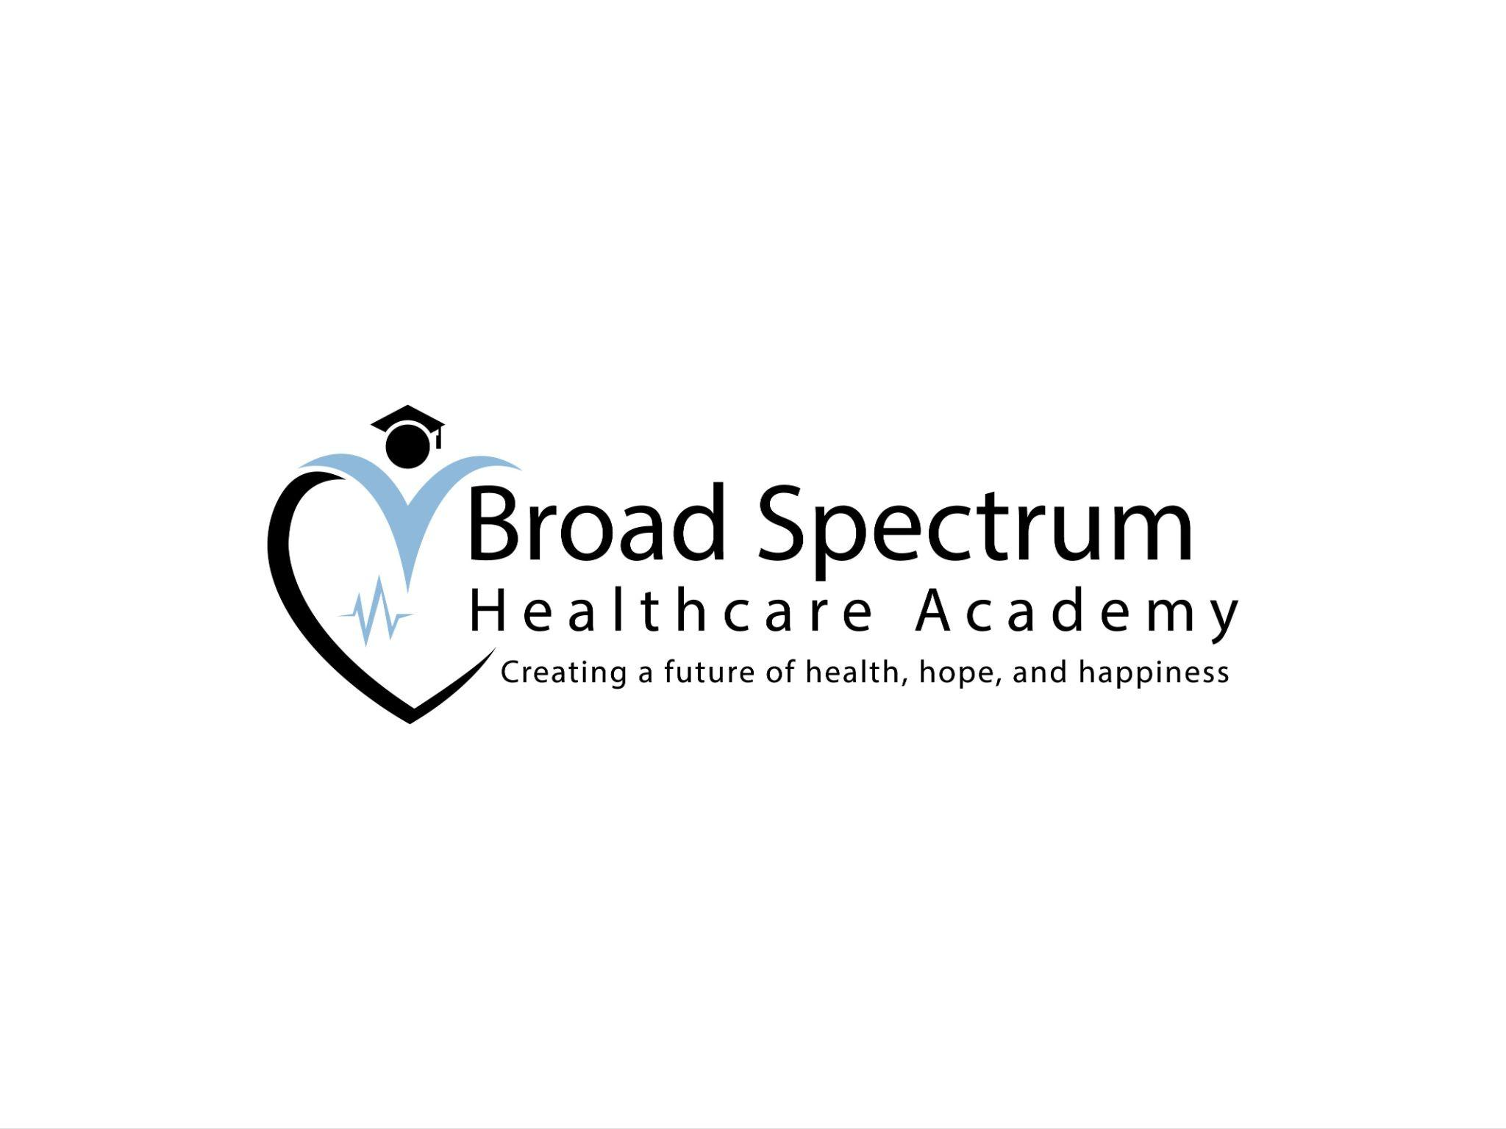

Broad Spectrum Healthcare Academy

CONSENT FOR RANDOM, OR REASONABLE SUSPICION DRUG TEST SCREEN AND RELEASE COVENANT NOT TO SUE AND INDEMNITY AGREEMENT

I, ________________ hereby CONSENT to allow Broad Spectrum Healthcare Academy to take a specimen of my hair, urine, or blood and submit it for a random, or reasonable suspicion drug test screen. I FURTHER CONSENT to allow the laboratory testing service to make the results of such screen available to Broad Spectrum Healthcare Academy.

In consideration for such services being rendered on my behalf, I hereby RELEASE the laboratory testing service, its officers, agents, and employees, from any and all claims which I might otherwise have due to such results being made so available. I hereby CONSENT NOT TO FILE ANY ACTION at law or in equity against Broad Spectrum Healthcare Academy, the laboratory testing service, their respective officers, agents or employees in connection with the results of such screen being made so available, and I hereby agree to INDEMNIFY and SAVE HARMLESS Broad Spectrum Healthcare Academy, the laboratory testing service, their respective officers, agents, and employees from all damages, expenses, reasonable attorney's fees, and costs of court which they or any of them may suffer or incur, jointly or severally, due to the results of such screen being made so available.

SIGNED this ___________day of _____________, 20___.

SIGNATURE __________________________________________________